Decoding lexical semantic information in temporoparietal cortices
Joon Hei Lee¹, Tianhao Lei², Prashanth R. Prakash¹, Robert D. Flint² (?), Matthew C. Tate^{2,4} (?), Joshua M. Rosenow^{2,4,5}, Jason K. Hsieh⁴, Joshua I. Glaser², Marc W. Slutzky^{1,2,3,5}
Departments of Biomedical Engineering¹, Neurology², Neuroscience³, Neurosurgery⁴, and Physical Medicine & Rehabilitation⁵, Northwestern University

Abstract

Introduction
<Background & lit review – taken from quals proposal… will need to edit + condense>
Each year, hundreds of thousands of adults suffer from neurological diseases or injuries such as stroke and traumatic brain injury (TBI), a large proportion of whom eventually develop persistent speech and language deficits. In the United States alone, roughly 795,000 people have a stroke annually¹; about two-thirds of acute stroke survivors face communication deficits², and one-third develop aphasia (which refers to acquired impairment of language production and/or comprehension)^{3,4}. Similarly, clinical series report aphasia in 15–20% of moderate or severe TBIs⁵. These impairments not only impede cognitive function, but also carry profound functional and psychosocial consequences². Patients with aphasia consistently report far lower quality of life⁴, along with high rates of depression and anxiety^{3,6}. Further, communication difficulties compound other stroke sequelae, leading to frustration, social isolation, and reduced access to rehabilitation and care³. There is therefore an urgent need for technologies that restore communication for these individuals.
Recent advances in brain-computer interfaces (BCIs) have made it possible to translate neural signals into meaningful speech output, such as phonemes⁷ (basic units of speech sounds) or reconstructed speech audio^{8,9}, in highly controlled settings. However, nearly all existing speech BCIs have leveraged signals tied to phonology and articulation found within the frontal lobe—primarily the ventral precentral and inferior frontal gyri^{7–12}. While these systems have demonstrated impressive decoding rates and accuracy in patients with dysarthria and anarthria caused by amyotrophic lateral sclerosis or brainstem stroke^{13–17}, they inherently exclude individuals with frontal lobe damage. Such individuals, who may experience deficits like expressive aphasia^{18,19} or apraxia of speech²⁰, cannot generate the frontal lobe signals required to control such BCIs. Consequently, a substantial population of linguistically-impaired patients remains without any viable technology to regain communication function. This constitutes a major clinical gap which further necessitates the development of alternative speech decoding strategies.
Temporoparietal signals encoding semantics could offer an alternate decoding approach. A promising alternative is to circumvent the damaged frontal motor pathways altogether, and decode using semantic information from the temporal and parietal lobes instead. Speech production is generally understood to unfold across several distinct processing stages, starting with conceptual preparation and ending in articulation^{21–24}. Lexical-semantic processing—the mapping of conceptual intent onto specific word forms²⁵—is a particularly tractable and ecologically relevant decoding target. Words are the primary currency of human communication, and decoding them directly from neural activity offers rapid and interpretable speech outputs^{26–28} without requiring reconstruction of full sentences or lower-level articulatory signals. Directly decoding these lexical-semantic representations from neural signals could thus serve as a more natural, efficient, and effective method of speech restoration.
Current literature indicates that the neural substrate of semantic processing is not confined to the frontal cortex, but distributed widely across an interconnected frontal-temporal-parietal network^{29–32}. Within this network, several key subregions within the temporal and parietal lobes have been implicated during semantic processing, such as the middle temporal gyrus^{29,33} (MTG), fusiform gyrus^{29,34,35} (FG); anterior temporal lobe^{36–39} (ATL); and inferior parietal lobule²⁹ (IPL) consisting of the supramarginal and angular^{34,40,41} gyri (SMG/AG). These findings imply that even if a patient’s ability to articulate speech is compromised due to frontal lobe damage, information related to the concepts they intend to convey is potentially still retained in temporoparietal cortices.
Despite the potential of this approach, there is still a need to better understand whether these higher-order semantic representations can be mapped to the specific words one intends to say. Most studies exploring semantics to date have typically characterized neural responses averaged across entire experimental blocks or conditions^{29,34,39,42}, rather than resolving the word-level semantic signals that a decoder must operate on. Moreover, many of these studies utilize speech perception or comprehension^{26,43,44} paradigms as opposed to speech production, making them suboptimal benchmarks for decoding intended speech. Consequently, it remains unclear whether the semantic representations identified in these contexts are sufficiently consistent and discriminable on a trial-by-trial basis to support reliable word-level decoding during production.
While a small number of studies have attempted to decode semantic information from electrophysiological or neuroimaging data^{36,38,44–49}, these efforts remain limited in scope. Existing work has demonstrated decoding of 2-3 broad semantic categories^{36,38,44} or coarse positions within semantic vector spaces^{45,48,49}, but has not resolved finer-grained distinctions approaching specific word identity⁴⁶. Spatiotemporally, prior characterizations are further constrained: fMRI studies^{48,49} offer strong spatial localization but lack precise enough temporal resolution⁵⁰ to resolve the rapid dynamics of lexical access^{22,23,51}, while the few studies that have examined semantic decoding using intracranial recordings have not explicitly targeted or isolated temporoparietal areas as the decoding source^{36,38,44–46}. Overall, questions remain as to whether more granular semantic information, including the exact word a speaker intends to produce, can be decoded from temporoparietal cortices alone—and if so, which subregions and which temporal features would be most informative for a BCI.
Here, we directly address the above gaps by leveraging high-resolution electrocorticography (ECoG) and stereo-electroencephalography (sEEG) recordings to characterize the granularity, timing, and spatial distribution of decodable lexical-semantic information within temporoparietal cortices, establishing the empirical foundation for a semantics-based speech BCI targeting patients with frontal lobe damage. First, we xxx. Then, we xxx, In the end, we xxxx.

Info on amodal semantic hub (should this be in intro or discussion?): An amodal semantic hub is real but graded: rTMS to either temporal pole disrupts word and picture semantics equally (Pobric 2010), ventral ATL responds to words/pictures/sounds alike while superior ATL is auditory-specific (Visser 2011), and RSA finds shared word/object structure only in parts of LpMTG/AG/IPS with LIPS truly modality-invariant (Devereux 2013). ECoG of visual vs auditory naming (Nakai 2019) shows they start in different sensory cortex and differ in timing/prefrontal profile but converge on a shared left-dominant network before speech onset. Cross-modal semantic decoding is feasible and largely shared across cortex (Tang 2025), and simple resampling fixes imbalance without overfitting (Buda 2017)

Results

Modality-independent, above-chance decoding of semantic category and word identity
- Peak pre-voice accs using all TP electrodes * [PN/category, PN/word, AN/category]
- Accs across time offsets using all TP electrodes * [PN/category, PN/word, AN/category]

Several temporoparietal subregions contribute most to lexical-semantic decoding
- Peak pre-voice accs by ROI * [PN/category, PN/word, AN/category]
- Visualization on cortical surface maps of ROI-level and single-electrode decoding

Tracing passage(?) of decodable lexical semantics across subregions
- Acc heatmaps of time x ROI

Lexical-semantic representations are (dynamic/static?) in temporoparietal cortices
- Train vs test heatmaps + diagonal plots, for a selection of ROIs – good if there are a few more dynamic and more static ROIs

Toward an extensible semantic decoding framework
- Alec’s work using the regression/retrieval -based decoding
- Demonstrate how this retrieval accuracy could be better choice for a generalizable decoding

A regression-and-retrieval decoder recovers word identity
To move from category-level classification toward an extensible word-level decoder, we explored replacing the fixed-class classifier with a regression-and-retrieval model. For each participant and time bin, a kernel partial-least-squares (PLS) regressor (Nyström-approximated RBF kernel followed by PLS; Methods) mapped the high-gamma feature vector onto a continuous word-embedding space, and the predicted embedding was decoded by nearest neighbor retrieval in the word-embedding space against a vocabulary database. We identified the optimal number of PLS components to be 10 (Supp Fig pls_components, Methods). Across the picture-naming cohort (n = 12), semantic category decoding and word-retrieval decoding at top-1, top-3 and top-5 (see Methods) were all reliably above chance and shared a common time course: accuracy rose shortly after picture onset, peaked at ~1.1 s, and returned toward baseline before articulation (voice onset 2.6 ± 1.5 s; Fig. regression_decoding_general). Independent category accuracy reached a peak of 0.309 ± 0.020 (mean ± s.e.m. across participants) against an empirical, permuted-label chance level of 0.157; significant decoding emerged 0.39 ± 0.19 s after picture onset and peaked at 1.08 ± 0.10 s (rise and peak latencies mean ± s.d.; n = 12). Word-retrieval accuracy scaled with k, and every level exceeded its own empirical permuted-label baseline: peak accuracy 0.042 ± 0.007 (top-1; baseline 0.013), 0.114 ± 0.015 (top-3; baseline 0.041) and 0.178 ± 0.022 (top-5; baseline 0.071) (mean ± s.e.m. across participants). Significant word decoding arose 0.67 ± 0.62 s (top-1, n = 10), 0.52 ± 0.26 s (top-3, n = 12) and 0.46 ± 0.26 s (top-5, n = 12) after picture onset and peaked at 1.32 ± 0.48 s, 1.18 ± 0.19 s and 1.13 ± 0.26 s, respectively (rise and peak latencies mean ± s.d.; two participants showed no significant top-1 decoding). {TODO: briefly compare to the previous classifier results.} These results complement the previous decoding performance obtained with a classifier.
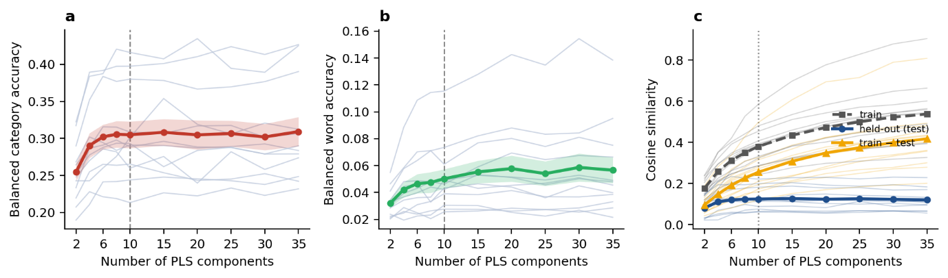
Selection of the number of PLS components Held-out performance metric as a function of the number of PLS components for picture naming task (kernel PLS regression: Nystroem kernel followed by PLS regression onto GloVe word-embedding targets). For every component the model was refit over repeated random train/test splits (70/30). Metrics are shown at the best-performing time bin. a Balanced category accuracy and b balanced word accuracy obtained from retrieval of the predicted embeddings against the true word embeddings. Shading denotes ± 1 s.e.m. Grey lines show individual participant. c Cosine similarity between predicted and true embeddings, shown for the training set (grey, dashed, square markers) and the held-out test set (blue, solid, circular markers). Yellow line (triangular markers): per-participant train-minus-test difference. Thin lines show individual participants for all three quantities; bold lines are across-participant means. a, b, c N=12.
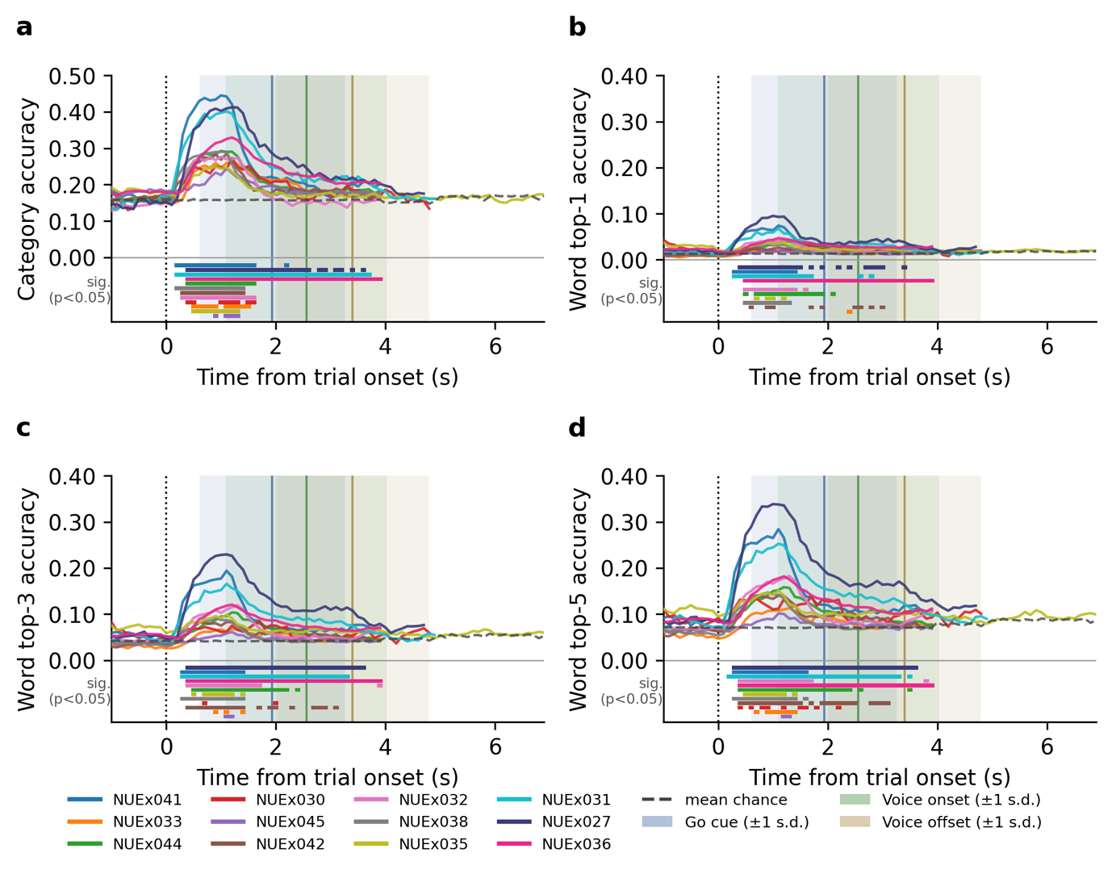
Figure Cross-patient semantic-decoding using a regression-retrieval based decoder. Held-out decoding accuracy as a
function of time for picture naming (N=12). a Independent balanced category accuracy. b-d top-1, top-3 and top-5 word-retrieval accuracy, respectively. Horizontal coloured bars below the chance line are a per-participant significance raster. Significance is calculated for each time bin separately (one-sided permutation test, p < 0.05; pre-onset bins are not tested). Dashed horizontal line: mean shuffled chance across participants. Dotted vertical line at 0 s: alignment cue (trial onset). Vertical coloured lines and shaded areas: mean cue time across participants ± 1 s.d..

Modality-independent semantic representations – i.e. control for perceptual
- A shared subset of ROIs is engaged in lexical-semantic decoding across both tasks – FG, pMTG, pITG …?
- Category retrieval within language vs visual embedding spaces. Decoded semantic information from picture is more likely to be language, instead of vision
Decoded semantic information reflects linguistic rather than visual structure
A central concern for any semantic decoder operating on a picture-naming task is whether it reads out the meaning of the intended word or merely the visual properties of the stimulus. We addressed this directly by regressing high-gamma activity onto two families of embedding model that are, by construction, blind to one another's information: language-only distributional models (GloVe, Word2Vec), trained purely on lexical co-occurrence, and vision-only self-supervised models with different architectures (DINOv3, a vision transformer; MoCo, a convolutional network), trained purely on images with no text or labels under a self-supervised paradigm. The two families are genuinely distinct representations of the same stimuli: a Procrustes analysis of the models' embedding spaces showed high within-family but low cross-family similarity — the two language models aligned at 0.73 and the two vision models at 0.51, whereas every language–vision pair aligned at only 0.29–0.44 (Procrustes similarity on the shared stimulus set; Fig. Language_vs_vision a).

Both families decoded semantic category above chance and followed a similar time course, rising after picture onset and peaking ~1.1 s later; but the language family carried more information throughout.
The advantage was strongest and most sustained in variance explained: the language−vision R² difference was significant across 36 bins spanning ~0.3–3.9 s (per-bin linear mixed model, participant random intercept, BH-FDR q < 0.05; Fig. Language_vs_vision b). The category-accuracy difference between the language and vision families was likewise significantly positive across 20 time bins, concentrated 0.4–1.5 s after picture onset (Fig. Language_vs_vision c).

At the moment semantic decoding peaked (~1.1 s), a pairwise model comparison confirmed the dissociation across metrics (one-sided Wilcoxon signed-rank, language > vision, BH-FDR over the 12 pair×metric tests; Fig. Language_vs_vision d). In variance explained, every language model exceeded every vision model: GloVe and Word2Vec each beat both DINOv3 and MoCo (Δ R² = 0.009–0.020, all q < 0.01, 11–12 of 12 participants). In category accuracy, both language models beat the transformer DINOv3 (GloVe > DINOv3 q < 0.01, Word2Vec > DINOv3 q < 0.05) and GloVe also beat MoCo (q < 0.05); only Word2Vec vs. the convolutional MoCo — the strongest vision competitor — was non-significant. Word-level decoding did not separate the families in any pairwise comparison.

The effect was consistent across the full cohort. Category decoding favored language over vision embeddings in 11 of 12 participants (one-sided Wilcoxon signed-rank p = 7.3 × 10⁻⁴; mean Δ = 0.006), while the weaker word-level decoding favored language in 8 of 12 (p = 0.088; Fig. Language_vs_vision e). Finally, the language advantage was not an artifact of using the vision models' default pooled representation: category and word decoding rose steadily from early to late layers of both vision networks (e.g. DINOv3 category accuracy 0.16 → 0.29 from layer 1 to 12; MoCo 0.23 → 0.28 to layer 5) — consistent with later layers encoding progressively higher-level, more semantic content and earlier layers low-level shape, colour and contour — yet the best-decoding layer of each still reached only the language decoder's level, not beyond it (best category accuracy DINOv3 0.290, MoCo 0.282, vs. the language reference 0.296; Fig. Language_vs_vision f).
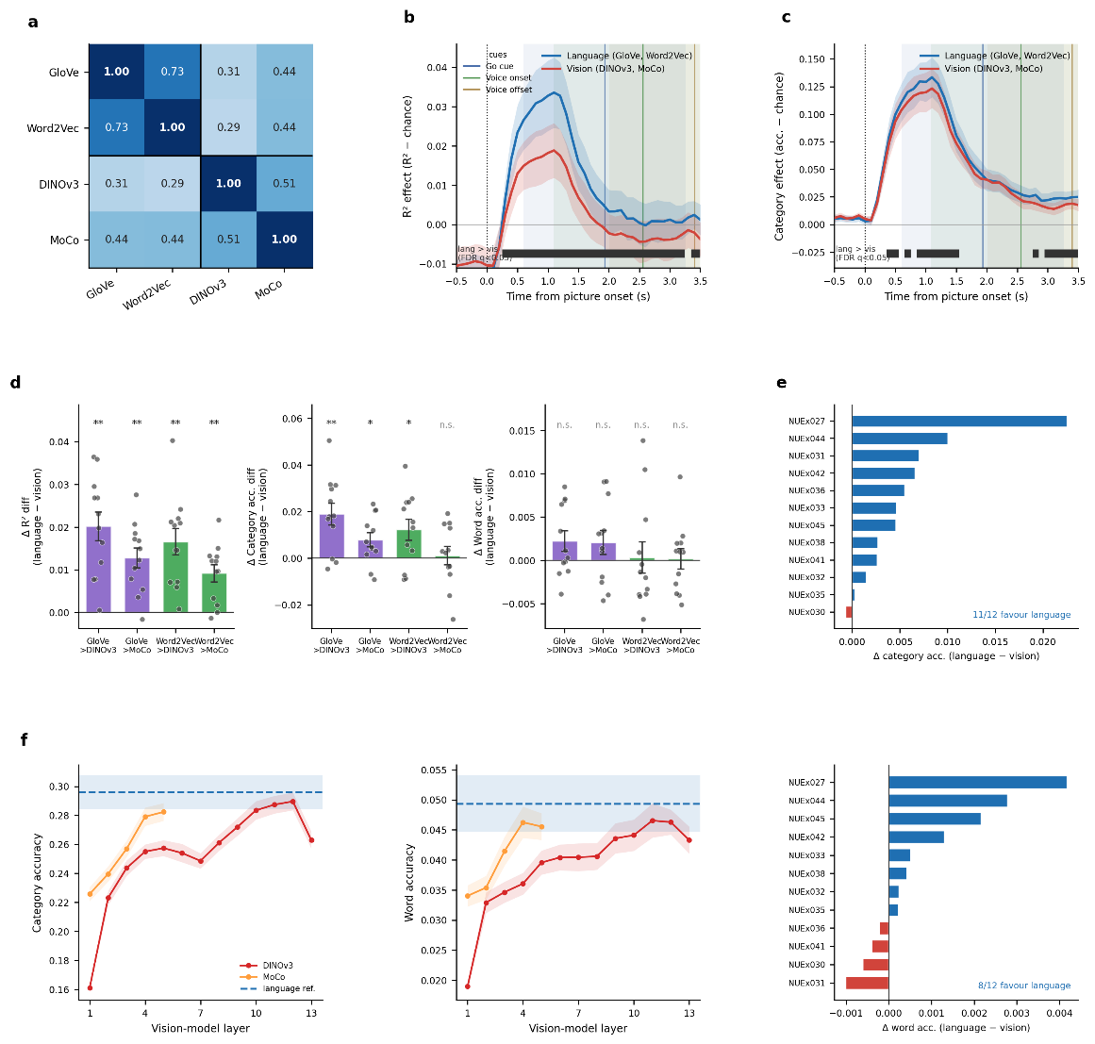
Figure Language_vs_vision Decoded semantic signals reflect linguistic rather than visual structure. a Procrustes similarity between the four embedding spaces on the shared stimulus set(1 − Procrustes disparity of the top-10-PC concept geometries; higher = more similar); black lines separate the language from the vision block. b Variance explained (R² − shuffled chance) and c category effect (balanced accuracy − shuffled chance)for the language vs. vision family (mean ± s.e.m.); bars below zero mark bins where language > vision (per-bin linear mixed model, participant random intercept, BH-FDR q < 0.05; pre-onset bins not tested). Vertical lines/bands: cue times (Go cue, voice onset, voice offset) mean ± 1 s.d. across participants. d At the peak bin (defined by the mean category-accuracy peak of all participants), pairwise difference Δ (language – vision) for each language > vision model pair, in R² (left), category (middle) and word (right) decoding; bar = group mean, error = s.e.m., dots = participants (jittered); stars = one-sided Wilcoxon signed-rank (language > vision), BH-FDR over the 12 pair × metric tests (*** q<0.001, ** q<0.01, * q<0.05, n.s. q≥0.05). e Between-participant difference Δ = language − vision in post-stimulus mean accuracy, ranked per participant for category and word; blue = favours language, red = favors vision. f Category (left) and word (right) accuracy of DINOv3 and MoCo across layer depth (1-indexed; mean ± s.e.m. over participants); dashed line = language decoder (GloVe, Word2Vec) pooled peak accuracy ± s.e.m. Dotted vertical line: picture onset (0 s). Participants are identified by display ID (NUEx###). N = 12.

The regression-and-retrieval decoder scales to open vocabulary and unseen words
Because the regression-based decoder predicts a vector in a continuous word-embedding space rather than selecting among a fixed set of labels, its predictions can be matched against an arbitrary word list without refitting. We tested this by ranking each trial's predicted vector in GloVe embedding space, measured by cosine similarity, against an open corpus that contained up to 5,000 most common concrete nouns including the words in our word list (Methods). The rank of the true word among the N gallery words indexes retrieval (chance median percentile rank 0.5; chance top-k accuracy k/N). Cross-validation held 30% of the unique words entirely out of training, so held-out trials test retrieval of words the decoder was never fit to produce (zero-shot). Against the full 5,000-word gallery, the true word fell in the top 2.1% of the ranked list (group median percentile rank 0.021; per-participant 0.011–0.042; Wilcoxon signed-rank against chance p = 2.4 × 10⁻⁴, the minimum attainable at n = 12; within-participant permutation p ≤ 0.01 in every participant, p < 0.001 in ten of twelve). Its median rank was 56–212 of 5,000. The true word was the single top choice on 0.7–6.5% of trials (chance 0.02%), fell within the top 10 on 17.2 ± 1.6% of trials (mean ± s.e.m.; chance 0.2%), and within the top 100 on 49.5 ± 2.1% (chance 2%; Fig. Extendibility a,b). Retrieval declined only gradually as the gallery grew: expanding it 25-fold (200 → 5,000 words) lowered the group median percentile rank from 0.154 to 0.022 — the true word's median rank rose only ≈ 3-fold (e.g. NUEx041, 18 → 56) against the 25-fold increase in distractors — and top-10 accuracy fell only from 0.255 to 0.172 (Fig. Extendibility a). Results were essentially identical for a raw, unmatched gallery (median percentile rank at N = 5,000, 0.022 for both).

Words held entirely out of training were still retrieved far above chance in the open-vocabulary retrieval. The group median percentile rank was 0.031 for held-out words (95% CI 0.027–0.052) versus 0.016 for in-vocabulary words (95% CI 0.014–0.023), both p = 2.4 × 10⁻⁴ against chance (Fig. Extendibility c). Every participant placed held-out words well below chance (per-participant 0.016–0.110; top 1.6–11.0% of the 5,000-word gallery) and above their own in-vocabulary level; across participants the seen-to-unseen change in median percentile rank was roughly twofold (0.016 → 0.031) rather than a return toward chance (1,840 held-out trials in total). The full per-trial held-out distribution and its graceful widening with gallery size are shown per participant in Supplementary Fig. S1.

When the true word was not ranked first, the retrieved words lay near it in meaning. Graded against WordNet Wu–Palmer similarity (Methods), the retrieval ranking reached a mean nDCG@100 of 0.65 (95% CI 0.635–0.654; per-participant 0.603–0.675, Methods). The mean Wu–Palmer similarity of the top-10 retrieved neighbors to the true word exceeded a matched random-draw null in every participant (observed 0.507–0.599 vs null 0.497–0.561), significantly so in ten (within-participant permutation p = 0.005); in the remaining two, NUEx030 and NUEx045, the differences were small and non-significant (p = 0.11 and p = 0.42), with an across-participant difference of +0.022 (Wilcoxon p = 2.4 × 10⁻⁴; Fig. Extendibility d). The same neural ranking also organized the whole retrieved list semantically: its nDCG@100 exceeded a matched permutation null in every participant (observed 0.603–0.675 vs null 0.590–0.641; median difference +0.018), significantly within-participant in eleven of twelve (NUEx045 at p = 0.055) and across participants (Wilcoxon p = 2.4 × 10⁻⁴; Fig. Extendibility e).

Projecting a well-decoded participant's predictions into two dimensions (t-SNE; NUEx027) makes this concrete: across diverse semantic categories the predicted embeddings land on the ground-truth word and its near-synonyms — e.g. mango→peach, cat→deer, spring→fall (Fig. Extendibility f). Per-trial percentile rank was only weakly related to word frequency (|r| = 0.01–0.19 across participants), indicating that retrieval was not explained by frequency. Illustrative best-case retrievals per participant are tabulated in Supplementary Table S2.

Importantly, this flexibility came at no measurable cost to category-level performance. Benchmarked against a conventional fixed-class classifier trained on the same participants to decode the six semantic categories directly (a support vector machine; collaborator analysis), the regression-and-retrieval decoder achieved closely matched category balanced accuracy (regression-and-retrieval 0.29 versus classifier XX) and a near-identical temporal profile, with both decoders peaking in the same post-stimulus time bin. The two approaches therefore recover the same category-level information with the same timing, yet only the regressionand-retrieval decoder additionally resolves word identity and supports openvocabulary, zero-shot extension (see Discussion).

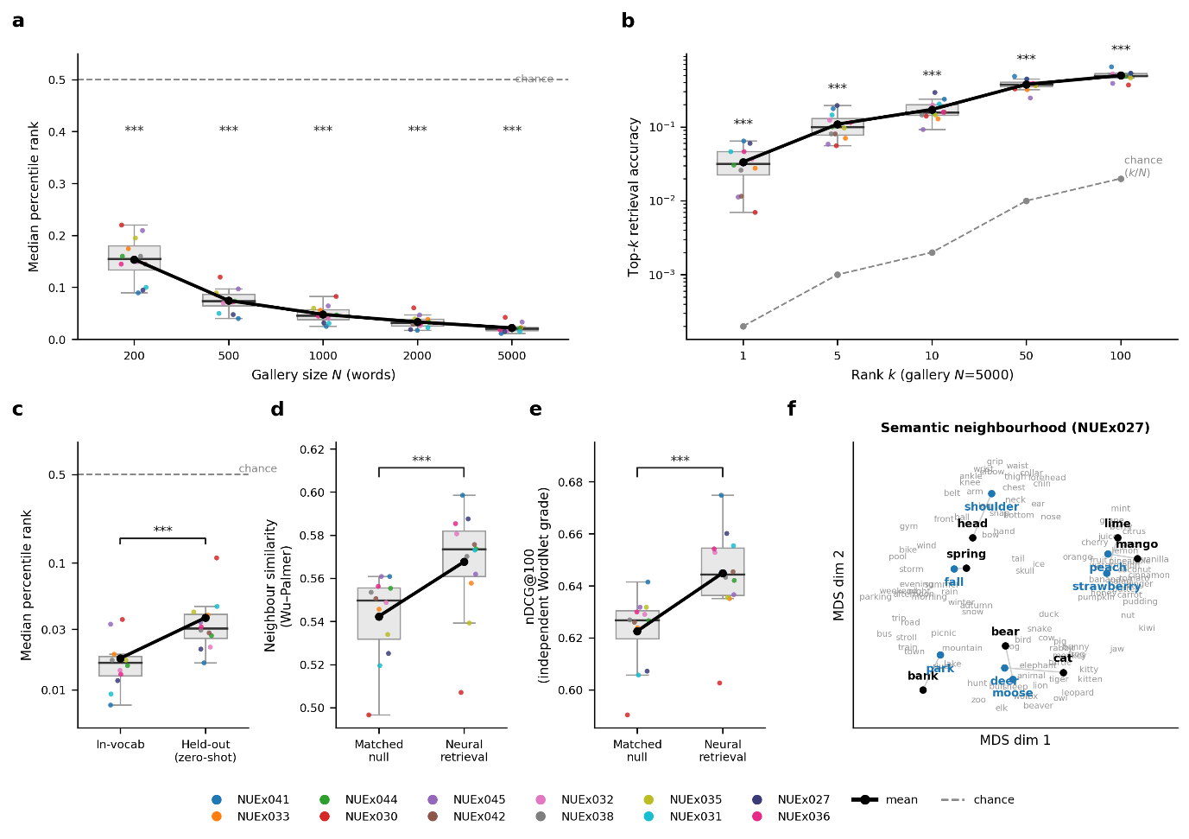
Figure Extendibility Extendibility of the regression-and-retrieval decoder (picture naming; num_patient=12). a Median percentile rank (rank/N; lower is better) versus gallery size N (200–5000 words); box, interquartile range and median across participants; colored points, individual participants; bold black, across-participant mean; stars, Wilcoxon signed-rank versus chance per N. b Top-k retrieval accuracy versus rank k at N=5000 (same box/points/mean convention; log y; dashed, chance k/N; stars, Wilcoxon versus chance per k). c Median percentile rank at N=5000 for words seen in training (in-vocab) versus words held entirely out of training (held-out, zero-shot; 30% of unique words held out per cross-validation split); box + points across participants; bracket, paired Wilcoxon (in-vocab versus held-out). d Wu–Palmer WordNet similarity between the true word and its top-10 retrieved neighbors, for a matched random-draw null versus the neural retrieval (WordNet grade is independent of the GloVe decode target). e nDCG@100 of the neural ranking versus the same matched permutation null (whole-list semantic organization under the independent grade). d, e: box + points across participants; bracket, group Wilcoxon of the observed-minus-null difference. f Two-dimensional MDS (cosine) of a best-participant semantic-neighborhood showcase: for several stimulus words of diverse semantic category, the predicted word (blue, bold; the top-retrieved gallery word at its own embedding) is shown beside the ground-truth word (black, bold) and their nearest gallery neighbors (grey); predictions land on the true word and its near-synonyms. a–e: box, interquartile range and median across participants; colored points, individual participants (one fixed color per participant); bold black, across-participant mean; dashed grey, chance. Group tests are Wilcoxon signed-rank (see Results). Participants identified by display ID (NUEx###). a–f num_patient=12. Supplements: S1, per-participant held-out per-trial percentile distributions across N; S2, qualitative best-case retrievals; S3–S4, semantic-neighborhood showcases for three further participants (S3: NUEx031, NUEx041; S4: NUEx036).

A single decoder co-trained on both tasks generalizes across modalities
We next asked whether one decoder could serve both speech tasks. For each participant who performed picture and auditory naming, we pooled the trials of both tasks and trained a single kernel-PLS semantic regressor; because picture naming trials greatly outnumbered auditory-naming trials, the auditory trials were upsampled so that the two tasks contributed equally to the pooled training set (Methods). The co-trained decoder performed above chance on held-out trials of both tasks (category-independent balanced accuracy: picture 0.241 ± 0.015, auditory 0.251 ± 0.015; chance 0.167; n = 6), retaining the large majority of each task-specific decoder's accuracy (picture, 78%; auditory, 87% of the within-task ceiling; Fig. R3a, Table R1). A single model can therefore decode semantic category from either modality without task-specific retraining, at modest cost relative to bespoke per-task decoders. Interrogating the co-trained model further localized the signal: the PLS variable-importance-in-projection (VIP) score assigns each electrode a weight reflecting its contribution to the shared semantic mapping, and roughly one third of electrodes per participant exceeded average importance (VIP > 1), forming a sparse set of high-importance, task-general electrodes (e.g., participant RB: V2, V3, V4; Fig. R3b). These electrodes— informative for semantic decoding in both tasks—are candidate targets for a future implant and candidate sites of an amodal, and shared semantic representation.

Discussion
Despite several cortical regions being proposed as possible substrates for semantic processing, mapping activity from these areas to specific speech output remains generally underexplored. Our study bridges this gap by demonstrating lexical-semantic decoding across a picture naming and auditory description naming task.
By performing decoding across 6 semantic categories and 15 individual words, we achieved a level of decoding granularity that has not been demonstrated to date, and which lends well to a future lexical-semantics-based speech BCI.
We characterized the spatiotemporal dynamics of decoding within temporoparietal cortices. Contributing subregions we identified will help narrow down potential implant targets for a semantic BCI, while the temporal profile of decodable semantic signal—including how dynamically it varies over time—could inform temporal feature extraction approaches in such systems. Moreover, decoding accuracy was significantly above chance prior to vocalization, which shows that […]
Critically, lexical-semantic decoding remained consistently above chance across both speech tasks, with XX, YY and ZZ emerging as common loci for decoding. This suggests that we were indeed decoding information related to semantics rather than perception of task-specific stimuli, and that these representations arise from modality-convergent semantic hubs. (tie to mid-Fus, pMTG etc. in Forseth et al)
Category decoding accuracy during the picture naming task was also better accounted for by language rather than visual embedding spaces, further indicating that the decoded signals represented linguistic meaning and not simply processing of visual stimuli.

Limitations/Future work
Study recruited language-intact pts – investigate decoding in aphasic population a la Tang 2026
Still a controlled expt setting – naturalistic speech a la Pescatore 2025
Moving from word-level to sentential/compositional outputs

Methods
We decoded semantic information from intracranial high-gamma activity using a patient-wise regression framework that mapped neural population responses onto continuous word-embedding spaces. Analyses were performed separately for each patient and task, with the cohort automatically defined by the presence of task-specific data files in the repository. Trial-wise preprocessing removed poor-quality trials and channels, and neural activity was binned at 100 ms resolution. At each decoding time point, the model used a temporally lagged neural feature vector comprising the current bin and the preceding nine bins, thereby capturing 1 s of recent neural history. For auditory naming, the pipeline further supported behavioral-event alignment and linear warping of the auditory stimulus period to normalize across variable stimulus durations.
Semantic targets were defined using lemmatized lexical labels and included both text-based and visual embedding models. The default decoder used kernel partial least squares, implemented as a Nyström approximation of an RBF kernel followed by partial least squares regression with 10 latent components, trained over 50 repeated random train-test splits. Model performance was assessed on held-out trials using both continuous and retrieval-based metrics. In addition to explained variance, we quantified the directional agreement between predicted and true embeddings using mean-centered cosine similarity, a measure designed to remove inflation arising from the shared centroid of the embedding space.
To assess lexical and semantic recovery, predicted embeddings were decoded by nearest-neighbor retrieval against a vocabulary-level embedding database. Word-level performance was quantified using exact top-k retrieval and macro-balanced accuracy. Category-level performance was quantified both by mapping the retrieved word to its category and, more stringently, by assigning each predicted embedding directly to the nearest category centroid in embedding space. This independent category metric provides a category-level readout that is not contingent on successful lexical decoding and therefore offers a more direct estimate of abstract semantic structure in the neural signal.

Study participants
All research activities were conducted under the oversight of the Northwestern University Institutional Review Board and in full compliance with Northwestern University ethical guidelines. Study participants were individuals who required intracranial electrode implantation for intractable epilepsy monitoring. Electrode placement was dictated entirely by clinical requirements for seizure localization and was not modified in any way to accommodate research objectives.
Research enrollment was considered only after a patient had had the electrodes implantation and been independently consented to the study. Prospective participants were evaluated against the following inclusion criteria: age 18 or older, right-hand dominance, sufficient cognitive and language production capacity to provide informed consent, and fluency in English. All enrolled participants provided written informed consent and retained the right to withdraw at any time without any impact on their clinical care. A total of 12 participants (five females, need to include mean age?) were enrolled in the study. No participant blinding or randomization procedures were employed.
Participants received standard clinical ECoG arrays (1 cm inter-electrode spacing and 2.3 mm electrode diameter; n=2) or sEEG electrodes (n=10). Electrode localization was performed by manually identifying contacts over the temporal and parietal lobes using co-registered preoperative MRI and postoperative CT imaging (see Co-registration below). For the participants with sEEG electrodes, any electrode contacts determined to lie within white matter were excluded from subsequent analyses.

Co-registration of electrodes

Experimental setup
All 12 participants performed a picture naming task (PN); a subset (n=7) of them additionally performed a naming to auditory description task (AN) (visualization of these should be in the results?). In the picture naming task, participants were shown a series of visual stimuli and instructed to wait for a go cue (green dot on a black background) after each stimulus before overtly naming the image using a single word. The auditory description naming task was structured similarly, but using auditorily presented definitions (mean duration XXX ± YYY s) as stimuli to be named. Stimuli were presented in a random order within each experiment block and without inter-trial intervals.
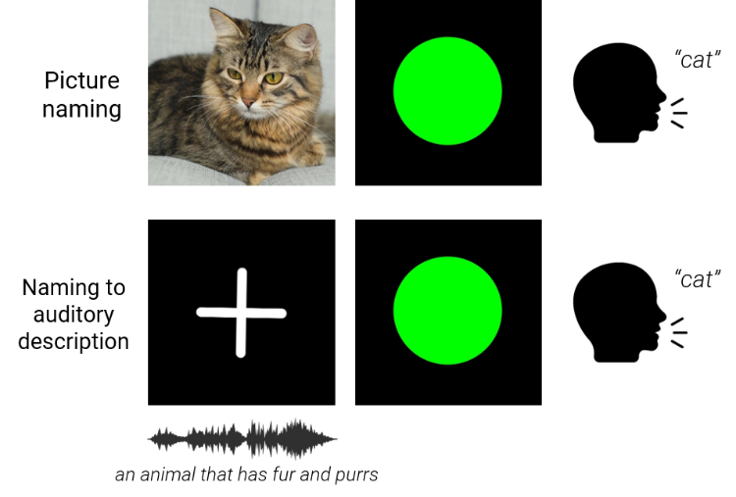
The set of target words used across both tasks was selected by referencing several established datasets: Neuropsychic clinical battery, Binder lab word set, and Yu et al.’s 50-word set⁵². We selected a total of 68 words, all of which had at most three syllables. We manually assigned each word to one of six semantic categories (e.g. animal, body part, vehicle), ensuring that categories were balanced in (i) word count and (ii)first phoneme. We further validated that the chosen categories were semantically relevant and distinct by examining the first three principal components of the word embedding space constructed by GloVe⁵³ vectors of all words in the dataset, and observing that the words were broadly separable into these categories within this space. The picture naming stimuli comprised three different colored photos per target word, all retrieved from Google search. Four participants performed older versions of the two tasks that consisted of slightly different word sets and category labels.
Language embeddings. We used two established distributional-semantic models that derive word meaning exclusively from lexical co-occurrence statistics, with no visual input. GloVe (Global Vectors for Word Representation; Pennington, Zinkov & Socher, 2014) was trained on the 840-billion-token Common Crawl corpus, yielding 300-dimensional vectors whose geometry encodes semantic similarity via log-bilinear co-occurrence statistics. Word2Vec (Mikolov et al., 2013) was trained on the Google News corpus (~100 billion words) using the skip-gram with negative sampling objective, also producing 300-dimensional vectors. Though both models produce similar-dimensional representations, they differ in training corpus and objective: GloVe directly factorizes a global co-occurrence matrix, whereas Word2Vec optimises local context-prediction. These models capture distributional-semantic structure—words that appear in similar linguistic contexts cluster together—but are entirely blind to the visual appearance of their referents.
Vision embeddings. We selected two self-supervised vision models that learn image representations without any language supervision, ensuring that explained neural variance cannot be attributed to implicit linguistic content. DINOv2-Small (Oquab et al., 2024) is a Vision Transformer trained with a self-supervised distillation objective (self-distillation with no labels) on the curated LVD-142M dataset. We extracted the CLS token from the final transformer layer, yielding a 384-dimensional embedding per stimulus image. MoCo (Momentum Contrast; He et al., 2020; Chen et al., 2021) uses a ResNet-18 backbone pre-trained with the MoCo-v2 self-supervised contrastive learning framework on the YFCC100M dataset (~100 million Flickr images) and subsequently fine-tuned on ImageNet-1k for feature refinement. We extracted the 512-dimensional embedding via global average pooling of the final convolutional stage. Both vision models were deliberately chosen to be language-free: neither DINOv2 nor MoCo incorporates text, captions, or class labels during representation learning. Any neural variance uniquely explained by these embeddings therefore reflects visual-perceptual rather than linguistic information.

Data acquisition and preprocessing
Neural signals were continuously recorded and digitized at 2 kHz using a Nihon Kohden system. We removed line noise by applying zero-phase delay notch filters at 60 Hz and its harmonics, and conducted iterative manual inspection of time- and frequency-domain signals to exclude electrodes and trials exhibiting excessive noise, epileptiform activity, or other artifacts from subsequent analyses. We then common average referenced signals from clean electrodes at the level of each ECoG grid or sEEG shank to attenuate common mode noise.
High-gamma (HG) band activity was extracted by bandpass filtering signals between 70–200 Hz with a causal, linear-phase finite impulse response (FIR) filter. We computed the analytic signal using the Hilbert transform and squared the amplitude envelope of this signal to obtain instantaneous HG power. The constant group delay introduced by the FIR filter was determined using τ=N-12⋅fs (where N was the number of filter taps and f_{s} the sampling rate), and subsequently corrected for by shifting the filtered HG power backwards in time by this delay amount.
We recorded audio using a unidirectional lapel microphone (Sennheiser) placed near the participant’s mouth; the audio signal was transmitted wirelessly (Califone) to a recording computer sampled at 48 kHz. Behavioral and neural recordings were time-synchronized via a common transistor-transistor logic (TTL) pulse recorded on both systems. We manually annotated all words spoken by the participants, along with their respective onset times, in the audio recordings using Audacity. We then segmented the continuous neural data into trial-wise epochs spanning from 500 ms pre-stimulus onset to 500 ms post-voice offset. Trials with no intelligible responses, or in which speech overlapped with an adjacent trial’s stimulus (and vice versa) were removed from analysis.

Feature selection

Stimulus durations varied across trials for both auditory description naming (due to each target word having a different description) and picture naming (durations were extended slightly in certain blocks if participants expressed difficulty finding names within the originally allotted time). To account for this, we linearly warped HG power within each stimulus segment to the median stimulus duration across trials for each patient. We thereafter downsampled each epoch’s HG time series into non-overlapping 100-ms bins, time-aligned to various behavioral events of interest: stimulus onset, go cue onset, and speech onset. Mean HG power within each bin was treated as a single neural feature for decoding. Our primary analyses relied on feature windows comprising a specific time bin of data and its preceding four bins (amounting to 5 bins and 500 ms per window), which were concatenated across all retained electrodes.

Neighborhood Components Analysis
A key challenge in neural decoding is identifying a putative low-dimensional subspace containing neural activity most informative for the target variable^{54–56}, particularly given the high dimensionality and inter-participant variability of ECoG/sEEG recordings^{57,58}. To address this, we applied neighborhood components analysis⁵⁹ (NCA)—a supervised dimensionality reduction technique that directly optimizes a distance metric to maximize leave-one-out classification accuracy in the projected space—to extract the neural feature dimensions most discriminative for semantic categories and word identity prior to decoding. Unlike unsupervised approaches such as principal component analysis⁶⁰ (PCA), NCA preserves and amplifies class-relevant structure in the data^{59–61}, making it particularly well-suited for decoding tasks where the relevant signal is sparse across the full feature space⁶². We determined the optimal number of embedding dimensions empirically by training and evaluating classifiers across a range of dimension counts (5-50) in a pilot subset of 3 participants. The dimensionality at which held-out decoding accuracy plateaued (15) was then uniformly applied to all remaining participants. The NCA-transformed features served as input to all subsequent classifiers.

Classification task
We performed decoding at two different granularities of lexical-semantic information: (i) semantic category and (ii) word identity. For each participant, we divided HG features across all trials into randomized stratified k-fold partitions (k=10); within each fold, one partition contained data held out for testing while remaining partitions were used for training. We trained and evaluated support vector machine (SVM) classifiers with radial basis function (RBF) kernels⁶³ using 5-fold cross-validation within the training set, optimizing decoder hyperparameters (regularization term C and kernel width γ) via grid search to maximize validation accuracy. We then retrained the best-performing model configuration on the full training subset, and tested on the held-out test set. We repeated this process over all folds to yield a stable estimate of mean test accuracy. To assess statistical significance, we compared observed test accuracy to an empirical null distribution derived by running the decoder on label-shuffled test sets 200 times. The test score obtained from a decoder was deemed significantly above chance if it was greater than or equal to the 95th percentile of the decoder’s null distribution.

Spatial characterization of lexical-semantic decoding

Region of interest specification and decoding
We assigned recording electrodes to anatomical regions of interest (ROIs) based on electrode coordinates derived from the above co-registration process. For each participant with sufficient coverage (≥3 electrodes) in a given ROI, we trained and evaluated separate SVM classifiers using only electrodes within that ROI. We then computed mean decoding accuracies across participants to yield group-level estimates, from which we identified the ROIs contributing the most to lexical-semantic decoding.

Single-electrode decoding
To corroborate and complement ROI-level analyses, we also performed decoding using individual electrode features. We projected single-electrode accuracy values onto participant-specific cortical surface reconstructions, and subsequently normalized them to a common brain surface for group-level visualization.

Temporal characterization of lexical-semantic decoding

Decoding through time
To identify the time course of decodable lexical-semantic information, we evaluated decoders using HG features extracted at varying time offsets relative to stimulus presentation, using a 500-ms sliding window of data across the trial duration. For each time offset, we computed a p-value using the permutation test described above, and thereafter corrected p-values across all offsets for false discovery rate (FDR) using the Benjamini-Hochberg method⁶⁴. We plotted decoding accuracy as a function of time to establish when semantic information became decodable above chance and when it peaked prior to speech onset.

Temporal generalization
Explain the train time vs test time matrix setup, and what it tells us. Remember to cite JRK here

Regression task
We used a two-stage pipeline consisting of a Nyström approximation of the radial basis function (RBF) kernel followed by partial least squares (PLS) regression with 10 components. The Nyström step approximates the RBF kernel mapping by computing kernel evaluations between each training sample and a random subset of 100 training observations (sklearn default), projecting the neural features into a 100-dimensional nonlinear feature space. PLS regression then identifies 10 latent components that maximize the covariance between the kernelized neural features and the full-dimensional embedding targets. Critically, PLS performs implicit dimensionality reduction on both sides of the mapping simultaneously: it extracts linear combinations of the input features and linear combinations of the target dimensions that are maximally covariant, without requiring a separate compression step on the embedding targets. This kernel PLS approach combines the capacity to capture nonlinear neural-to-semantic mappings with robustness to the high-dimensional, multicollinear structure of multi-channel intracranial data.
Selection of the number of PLS components
The number of PLS latent components governs a bias–variance trade-off: too few components underfit the neural-to-semantic mapping, whereas too many fit training-set idiosyncrasies and generalize poorly. We fixed this hyperparameter by sweeping the number of components from 2 to 35 and evaluating the peak accuracy across all time bins in held-out trials over repeated train/test splits in seven participants with GloVe model. Held-out mean-centered cosine similarity, balanced category accuracy and balanced word accuracy rose steeply up to roughly six to ten components and then plateaued (category accuracy 0.339 at ten components, ≥99% of the maxima observed within the comparable range, both of which occurred at fifteen components), whereas the train–test cosine similarity gap grew monotonically with component count (0.04 at two, 0.15 at ten, 0.22 at fifteen, and 0.27 at twenty components), indicating progressively worse overfitting with no held-out benefit. Ten components sat at the elbow of this trade-off—capturing essentially all recoverable held-out performance while keeping the generalization gap small—and were used for all regression analyses (Supplementary Fig. Sx).
Cross-task co-training and electrode importance
To test whether one decoder could serve both speech tasks, we pooled picture and auditory-naming trials within each participant who performed both, restricting to the intersection of channels present in both tasks and aligning each task at its own category-decoding peak bin. Because picture trials outnumbered auditory trials, we balanced the pooled training set by random upsampling of the minority (auditory) trials to equal counts before fitting; simple resampling of this kind corrects task imbalance without inducing overfitting in this setting. A single kernel-PLS regressor (ten components, as above) was then trained on the balanced pool and evaluated on held-out trials of each task over repeated bootstrap splits, alongside task-specific (within-task) and transfer (train-one/test-other) decoders sharing the same test folds. Decoding was scored with word balanced accuracy, an independent category-centroid metric, and mean-centered cosine similarity, each split into trials of words seen versus unseen in that model's training set. Electrode importance for the co-trained model was quantified by the PLS variable importance-in-projection (VIP) statistic, which summarizes each channel's contribution across the retained latent components; channels with VIP > 1 (above average importance) were treated as the high-importance set, and per-electrode cross-task semantic encoding was additionally assessed by representational similarity analysis against the embedding geometry computed separately for each task.
Linguistic versus visual attribution
To determine whether decoded picture-naming activity reflected linguistic meaning or visual stimulus properties, we compared regression onto language only embeddings (GloVe, Word2Vec, ConceptNet) against regression onto visiononly self-supervised embeddings (DINOv2, DINOv3, MoCo) using the identical kernel-PLS pipeline and retrieval metric. For each participant, embedding family, and time bin we computed the above-chance decoding effect relative to the participant's permutation null, and summarized each participant by the mean post-stimulus above-chance effect for the language and visual families. Family preference was tested across participants with a two-sided Wilcoxon signed-rank test (language versus visual effect) for both word and category accuracy. The time-resolved language-minus-visual difference was tested bin-by-bin with a linear mixed model (random intercepts for participant), correcting across bins for false discovery rate. Because the vision models are trained without any text, captions, or labels and the language models without any images, neural variance uniquely captured by each family can be attributed to visual-perceptual versus linguistic distributional structure, respectively.
Cross-validation and permutation null. For each embedding model and each time bin independently, we performed 100 iterations of random train/test splitting (70%/30%). On each iteration, the Nyström kernel approximation and PLS regression were fit on the training set and applied to the held-out test set, yielding predicted embedding vectors for each test trial in the original embedding space. To establish a chance baseline, the training neural features were element-wise permuted (destroying trial-to-feature correspondence while preserving marginal statistics), the full pipeline was re-fit on the shuffled data, and retrieval was evaluated on the same test set. Goodness-of-fit was assessed by the mean cosine similarity between mean-centered predicted and true embeddings.
Word retrieval accuracy
Predicted embeddings were evaluated by retrieval against a vocabulary database. For each unique word in the stimulus set, a single representative embedding was computed as the mean across all trials of that word, yielding a database of W canonical word vectors. For language embeddings (GloVe, Word2Vec), this averaging is trivial: every trial of a target word maps to the same fixed vector, so the mean reduces to deduplication. For vision embeddings (DINOv2-Small, MoCo), each word is depicted by three distinct image variants across trials, each producing a different embedding; the mean therefore averages across these visual depictions, yielding a single image-level representation per word that is not tied to any exemplar. Both the database and the predicted test embeddings were then mean-centered by subtracting the database centroid (the mean across all W word entries), so that retrieval operated on deviations from the average word representation rather than on absolute positions in embedding space. The decoded word for each test trial was assigned by nearest-neighbor lookup under cosine distance in this centered space:
$$ŵᵢ = argmin_{w}\left( 1 -\cos\left( ŷᵢ - μ, ēw - μ \right)\right)$$
where μ is the database centroid, ēw is the mean embedding of word w, and ŷᵢ is the predicted embedding for test trial i. Top-1 word accuracy is the fraction of test trials for which the retrieved word matches the true word identity. Top-3 and top-5 accuracy relax the criterion to whether the true word appears among the 3 or 5 nearest database entries, respectively. Word balanced accuracy is the macro-averaged recall across word classes, $BA =\frac{\left(\frac{1}{C}\right)Σ_{c}TP_{c}}{\left(TP_{c}+ FN_{c}\right)}$ , where C is the number of unique words represented in the test set. Macro F1 is computed analogously across the same word labels.
Category retrieval accuracy
To calculate category retrieval accuracy, the model predicts semantic category by comparing the cosine distance of the predicted embedding to the centroid of different semantic categories in the word embedding space. A centroid is formed from the mean-centered word embeddings, and each predicted embedding is assigned to the nearest category centroid:
$centroid_{c}= average of \left(e_{w}- mu\right)$ over all words w in category c
$cat_{hat_{i}}$ = argmin over categories c of
$$1 - cosine\left( y_{pred_{i}}- mu , centroid_{c}\right)$$
Category accuracy is then computed by comparing cat_hat_i with the true category label. Category balanced accuracy is the macro-average recall across semantic categories, using the same balanced-accuracy definition as above. This is the cleanest category-level measure in the repository because it quantifies category information even when the exact lexical item is not recovered.
Statistical tests
This section is subject to change.

References
1. CDC. Stroke facts. Stroke https://www.cdc.gov/stroke/data-research/facts-stats/index.html (2024).
2. Stroke Association. Communication problems. https://www.stroke.org.uk/stroke/effects/aphasia/communication-problems.
3. Bueno-Guerra, N. et al. Impact of post-stroke aphasia on functional communication, quality of life, perception of health and depression: A case-control study. Eur J Neurol 31, e16184 (2024).
4. Berthier, M. L. Poststroke aphasia: Epidemiology, pathophysiology and treatment. Drugs Aging 22, 163–182 (2005).
5. Safaz, I., Alaca, R., Yasar, E., Tok, F. & Yilmaz, B. Medical complications, physical function and communication skills in patients with traumatic brain injury: a single centre 5-year experience. Brain Inj 22, 733–739 (2008).
6. Hilari, K., Needle, J. J. & Harrison, K. L. What are the important factors in health-related quality of life for people with aphasia? A systematic review. Arch Phys Med Rehabil 93, S86-95 (2012).
7. Mugler, E. M. et al. Direct classification of all American English phonemes using signals from functional speech motor cortex. J Neural Eng 11, 035015 (2014).
8. Angrick, M. et al. Speech synthesis from ECoG using densely connected 3D convolutional neural networks. J. Neural Eng. 16, 036019 (2019).
9. Anumanchipalli, G. K., Chartier, J. & Chang, E. F. Speech synthesis from neural decoding of spoken sentences. Nature 568, 493–498 (2019).
10. Guenther, F. H. et al. A wireless brain-machine interface for real-time speech synthesis. PLOS ONE 4, e8218 (2009).
11. Leuthardt, E. C. et al. Using the electrocorticographic speech network to control a brain-computer interface in humans. J Neural Eng 8, 036004 (2011).
12. Luo, S., Rabbani, Q. & Crone, N. E. Brain-computer interface: Applications to speech decoding and synthesis to augment communication. Neurotherapeutics 19, 263–273 (2022).
13. Moses, D. A. et al. Neuroprosthesis for decoding speech in a paralyzed person with anarthria. N Engl J Med 385, 217–227 (2021).
14. Metzger, S. L. et al. A high-performance neuroprosthesis for speech decoding and avatar control. Nature 620, 1037–1046 (2023).
15. Willett, F. R. et al. A high-performance speech neuroprosthesis. Nature 620, 1031–1036 (2023).
16. Card, N. S. et al. An accurate and rapidly calibrating speech neuroprosthesis. New England Journal of Medicine 391, 609–618 (2024).
17. Wairagkar, M. et al. An instantaneous voice-synthesis neuroprosthesis. Nature 1–8 (2025) doi:10.1038/s41586-025-09127-3.
18. Patterson, J. Aphasia. in Encyclopedia of Clinical Neuropsychology (eds Kreutzer, J. S., DeLuca, J. & Caplan, B.) 217–223 (Springer, New York, NY, 2011). doi:10.1007/978-0-387-79948-3_858.
19. Eling, P. & Whitaker, H. History of aphasia: A broad overview. Handb Clin Neurol 185, 3–24 (2022).
20. Kirshner, H. S. & Samuels, M. A. Speech and language disorders. in Neurologic Localization and Diagnosis (eds Zimmerman, E. E., Samuels, M. A., Kirshner, H. S. & Misulis, K. E.) 177–189 (Elsevier, New Delhi, 2023). doi:10.1016/B978-0-323-81280-1.00031-7.
21. Indefrey, P. & Levelt, W. J. M. The spatial and temporal signatures of word production components. Cognition 92, 101–144 (2004).
22. Indefrey, P. The spatial and temporal signatures of word production components: a critical update. Front Psychol 2, 255 (2011).
23. Sahin, N. T., Pinker, S., Cash, S. S., Schomer, D. & Halgren, E. Sequential processing of lexical, grammatical, and phonological information within broca’s area. Science 326, 445–449 (2009).
24. Hickok, G. Computational neuroanatomy of speech production. Nat Rev Neurosci 13, 135–145 (2012).
25. Menenti, L., Petersson, K. M. & Hagoort, P. From reference to sense: how the brain encodes meaning for speaking. Front. Psychol. 2, (2012).
26. Jamali, M. et al. Semantic encoding during language comprehension at single-cell resolution. Nature 631, 610–616 (2024).
27. Grady, C. L., McIntosh, A. R., Rajah, M. N. & Craik, F. I. M. Neural correlates of the episodic encoding of pictures and words. Proceedings of the National Academy of Sciences 95, 2703–2708 (1998).
28. Fliessbach, K., Buerger, C., Trautner, P., Elger, C. E. & Weber, B. Differential effects of semantic processing on memory encoding. Hum Brain Mapp 31, 1653–1664 (2010).
29. Binder, J. R., Desai, R. H., Graves, W. W. & Conant, L. L. Where is the semantic system? A critical review and meta-analysis of 120 functional neuroimaging studies. Cereb Cortex 19, 2767–2796 (2009).
30. Huth, A. G., de Heer, W. A., Griffiths, T. L., Theunissen, F. E. & Gallant, J. L. Natural speech reveals the semantic maps that tile human cerebral cortex. Nature 532, 453–458 (2016).
31. Fedorenko, E., Nieto-Castañon, A. & Kanwisher, N. Lexical and syntactic representations in the brain: An fMRI investigation with multi-voxel pattern analyses. Neuropsychologia 50, 499–513 (2012).
32. Fedorenko, E. et al. Neural correlate of the construction of sentence meaning. Proceedings of the National Academy of Sciences 113, E6256–E6262 (2016).
33. Riès, S. K. et al. Spatiotemporal dynamics of word retrieval in speech production revealed by cortical high-frequency band activity. Proc. Natl. Acad. Sci. U.S.A. 114, (2017).
34. Forseth, K. J. et al. A lexical semantic hub for heteromodal naming in middle fusiform gyrus. Brain 141, 2112–2126 (2018).
35. Turker, S., Kuhnke, P., Eickhoff, S. B., Caspers, S. & Hartwigsen, G. Cortical, subcortical, and cerebellar contributions to language processing: A meta-analytic review of 403 neuroimaging experiments. Psychol Bull 149, 699–723 (2023).
36. Chen, Y. et al. The ‘when’ and ‘where’ of semantic coding in the anterior temporal lobe: Temporal representational similarity analysis of electrocorticogram data. Cortex 79, 1–13 (2016).
37. Cox, C. R. et al. Representational similarity learning reveals a graded multidimensional semantic space in the human anterior temporal cortex. Imaging Neuroscience 2, imag–2–00093 (2024).
38. Frisby, S. L. et al. All spectral frequencies of neural activity reveal semantic representation in the human anterior ventral temporal cortex. 2025.04.17.649404 Preprint at https://doi.org/10.1101/2025.04.17.649404 (2025).
39. Ralph, M. A. L., Jefferies, E., Patterson, K. & Rogers, T. T. The neural and computational bases of semantic cognition. Nat Rev Neurosci 18, 42–55 (2017).
40. Mitchell, T. M. et al. Predicting human brain activity associated with the meanings of nouns. Science 320, 1191–1195 (2008).
41. Seghier, M. L., Fagan, E. & Price, C. J. Functional subdivisions in the left angular gyrus where the semantic system meets and diverges from the default network. J Neurosci 30, 16809–16817 (2010).
42. Patterson, K., Nestor, P. J. & Rogers, T. T. Where do you know what you know? The representation of semantic knowledge in the human brain. Nat Rev Neurosci 8, 976–987 (2007).
43. Luo, X., Chen, H.-H. & Guo, Q. Semantic communications: overview, open issues, and future research directions. IEEE Wireless Commun. 29, 210–219 (2022).
44. Wang, W., Degenhart, A. D., Sudre, G. P., Pomerleau, D. A. & Tyler-Kabara, E. C. Decoding semantic information from human electrocorticographic (ECoG) signals. Annu Int Conf IEEE Eng Med Biol Soc 2011, 6294–6298 (2011).
45. Rupp, K. et al. Semantic attributes are encoded in human electrocorticographic signals during visual object recognition. NeuroImage 148, 318–329 (2017).
46. Pescatore, C. R. C. et al. Decoding semantics from natural speech using human intracranial EEG. 2025.02.10.637051 Preprint at https://doi.org/10.1101/2025.02.10.637051 (2025).
47. Carota, F., Schoffelen, J.-M., Oostenveld, R. & Indefrey, P. Parallel or sequential? Decoding conceptual and phonological/phonetic information from MEG signals during language production. Cognitive Neuropsychology 40, 298–317 (2023).
48. Tang, J., LeBel, A., Jain, S. & Huth, A. G. Semantic reconstruction of continuous language from non-invasive brain recordings. Nat Neurosci 26, 858–866 (2023).
49. Tang, J. & Huth, A. G. Semantic language decoding across participants and stimulus modalities. Current Biology 35, 1023-1032.e6 (2025).
50. Dale, A. M. et al. Dynamic statistical parametric mapping: combining fMRI and MEG for high-resolution imaging of cortical activity. Neuron 26, 55–67 (2000).
51. Flinker, A. et al. Redefining the role of Broca’s area in speech. Proceedings of the National Academy of Sciences 112, 2871–2875 (2015).
52. Yu, L. et al. A left-lateralized dorsolateral prefrontal network for naming. Preprint at https://doi.org/10.1101/2024.05.15.594403 (2024).
53. Pennington, J., Socher, R. & Manning, C. Glove: Global Vectors for Word Representation. in Proceedings of the 2014 Conference on Empirical Methods in Natural Language Processing (EMNLP) 1532–1543 (Association for Computational Linguistics, Doha, Qatar, 2014). doi:10.3115/v1/D14-1162.
54. Jazayeri, M. & Ostojic, S. Interpreting neural computations by examining intrinsic and embedding dimensionality of neural activity. Curr Opin Neurobiol 70, 113–120 (2021).
55. Prakash, P. R. et al. Decoding speech intent from non-frontal cortical areas. J. Neural Eng. 22, 016024 (2025).
56. Weber, J. et al. Subspace partitioning in the human prefrontal cortex resolves cognitive interference. Proceedings of the National Academy of Sciences 120, e2220523120 (2023).
57. Spalding, Z. et al. Shared latent representations of speech production for cross-patient speech decoding. 2025.08.21.671516 Preprint at https://doi.org/10.1101/2025.08.21.671516 (2025).
58. Mentzelopoulos, G. et al. Neural decoding from stereotactic EEG: accounting for electrode variability across subjects. Advances in Neural Information Processing Systems 37, 108600–108624 (2024).
59. Goldberger, J., Roweis, S., Hinton, G. & Salakhutdinov, R. Neighbourhood components analysis. in Proceedings of the 18th International Conference on Neural Information Processing Systems 513–520 (MIT Press, Cambridge, MA, USA, 2004).
60. Jolliffe, I. T. & Cadima, J. Principal component analysis: a review and recent developments. Philos Trans A Math Phys Eng Sci 374, 20150202 (2016).
61. Ding, X. et al. Study of MI-BCI classification method based on the Riemannian transform of personalized EEG spatiotemporal features. MBE 20, 12454–12471 (2023).
62. Lippitt, W. et al. Limitations of Clustering with PCA and Correlated Noise. J Stat Comput Simul 94, 2291–2319 (2024).
63. Hearst, M. A., Dumais, S. T., Osuna, E., Platt, J. & Scholkopf, B. Support vector machines. IEEE Intell. Syst. Their Appl. 13, 18–28 (1998).
64. Benjamini, Y. & Hochberg, Y. Controlling the false discovery rate: a practical and powerful approach to multiple testing. Journal of the Royal Statistical Society. Series B (Methodological) 57, 289–300 (1995).

